ta

A Peek at Our Week

Week of August 1-5, 2016



**Ah-“Mason” Happenings in the Fifth Grade**

Week of September 11-15



Dear Parents,

Please remember that we will be hosting our fall Parent Academy night on Monday, September 11, 2017 at 6:00. At this meeting, we will discuss a skill that has been identified as a priority and provide you with data specific to your child’s performance. We will provide you with materials and suggestions you can use at home to help your child continue to grow academically. The meeting is expected to last approximately 30 to 45 minutes, and childcare will be provided.

Many of our students rely on receiving weekly snack packs. This year, Hill City Elementary is responsible for collecting cans of Vienna sausages. We will be collecting these all year long and would greatly appreciate any donation that you can contribute. There will be a collection box located outside of the media center.

Thank you,

Fifth Grade Teachers

Follow our school on Twitter @HillCityHawks.



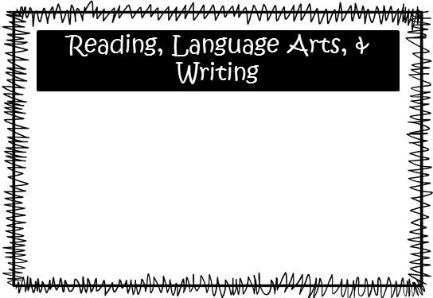

Please consider donating Vienna sausages for Snack Packs!

Upcoming Events:

* September 11th, Parent Academy
* September 18th-22nd: Fall Break, No School
* October 2nd, Title I Meeting
* October 6th, PTO Fall Festival
* October 18th, 50’s Dance for 4th and 5th Grade

Email Addresses:

[Amandalo@pickenscountyschools.org](mailto:Amandalo@pickenscountyschools.org)

[Ashleypatterson@pickenscountyschools.org](mailto:Ashleypatterson@pickenscountyschools.org)

Brandimcentire@pickenscountyschools.org

[Carolsmith@pickenscountyschools.org](mailto:Carolsmith@pickenscountyschools.org)

Jenniferwilds@pickenscountyschools.org

Things to Know

Science: **McEntire:** We will test over cells and microorganisms on September 14th. A study guide is in your child’s folder.

**Lo:** We will be moving onto the science classification of organisms.

Social Studies: Students will be wrapping up their studies of the Civil War. **Mrs. Lo’s students will test over the Civil War on September 13th, and Mrs. Wilds’ students will test on September 15th.**

On Monday, September 11th, students will experience a firsthand account from Mr. Lo who was in New York during the attacks on the World Trade Center.

We will be, hopefully, finishing up our first novel, *The Mostly True Adventures of Homer P. Figg.* Through the novel and an informational text, we will continue to focus on improving our reading comprehension and fluency. **We will not have a vocabulary test**. Students will also continue to practice writing compound and complex sentences, as well as, sentences with dialogue and interjections. Students have been working very hard on their first big writing assignment as 5th graders, and we are so proud of their hard work! We cannot wait to read the finished products and share them with you!

**Smith and Wilds:** We are working on division and will begin larger digit division with two digit divisors. Through models, decomposing, and the algorithm, we will work to solve these larger digit problems.

**McEntire’s Homeroom:** We are working on division, as well as, continuing with multiplying whole numbers.

Math