ta

A Peek at Our Week

Week of August 1-5, 2016

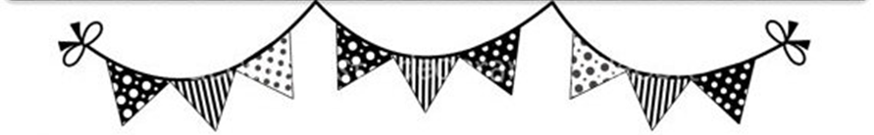

**Ah-“Mason” Happenings in the Fifth Grade**

Week of October 30-November 3



Follow our school on Twitter @HillCityHawks.

Dear Parents,

Students are allowed to dress up on Tuesday, October 31st but please note that masks and weapons, real or perceived, are **NOT** allowed. That morning we will also be hosting our “Donuts for Dudes.” Please keep this in mind as traffic congestion will be a major problem during morning drop off. We will **NOT** have tutoring this day. Next week we will celebrate Red Ribbon Week.

Monday- My future is so bright I need to wear shades. Wear sunglasses.

Tuesday- Don't let drugs make your life scary.  Wear a HAPPY Halloween Costume- NO MASKS, FACE PAINT, GORE, or SCARY things.

Wednesday- Give drugs the boot. Wear your cowboy boots.

Thursday- Don't be a target for drugs. Dress in Camouflage.

Friday- I am too smart for drugs. Dress like what you want to be when you grow up.

Thank you,

Fifth Grade Teachers

 We

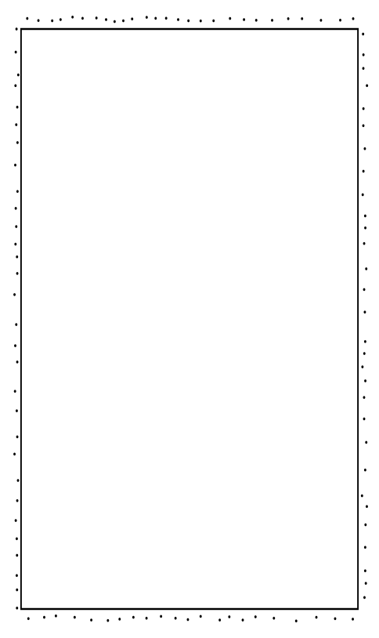

Things to Know

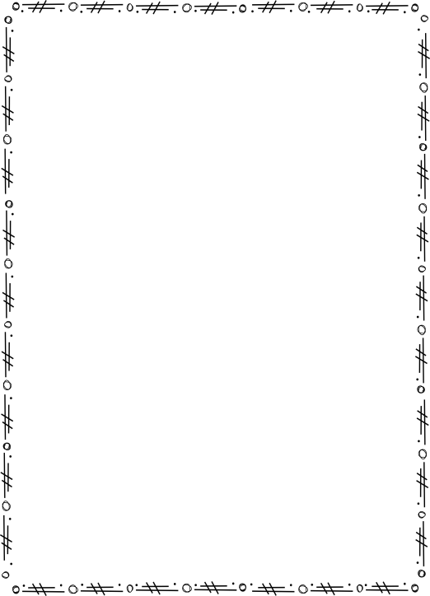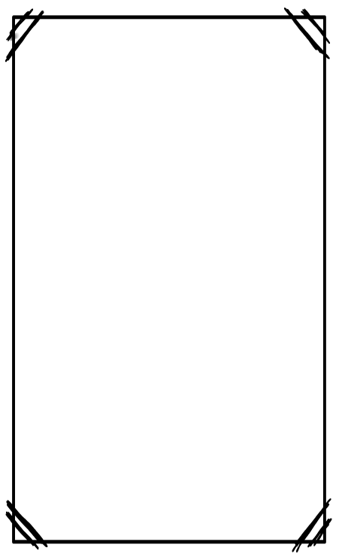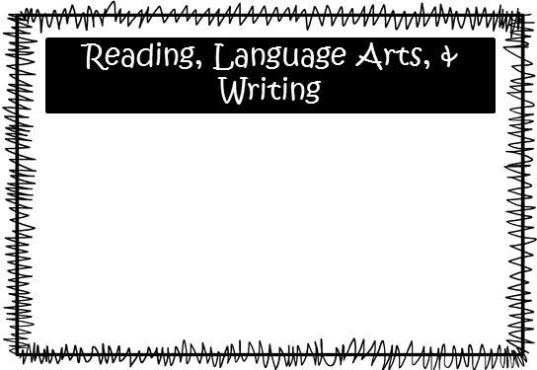.the

Science: We will continue our studies of landforms and the technology used to investigate and gather data to interpret changes in the Earth’s surface.

Social Studies: We are moving into immigration and will be testing over the Turn of the Century on November 3rd.

**Smith:** We will be adding and subtracting with decimals.

**McEntire’s Homeroom:** We are moving into multiplying decimals, as well as, reviewing previous skills.

**Wilds’ Homeroom:** We are moving into dividing decimals, as well as, reviewing previous skills.

Please consider donating Vienna sausages for Snack Packs!

Upcoming Events:

* October 31st—“Donuts for Dudes” and Dress Up Day (book character, Mad Scientist, etc.)
* November 3rd—Wear a Hat Dollar Day
* November 7th—Inservice Day, no school for students
* November 10th—Progress Reports and PTO Santa Night at 6:00PM
* November 20th-24th—Thanksgiving Holidays

Email Addresses:

[Amandalo@pickenscountyschools.org](mailto:Amandalo@pickenscountyschools.org)

[Ashleypatterson@pickenscountyschools.org](mailto:Ashleypatterson@pickenscountyschools.org)

Brandimcentire@pickenscountyschools.org

[Carolsmith@pickenscountyschools.org](mailto:Carolsmith@pickenscountyschools.org)

Jenniferwilds@pickenscountyschools.org

We will continue to follow our main character, Bud, and learn more about how his story will end in our novel, *Bud, Not Buddy.* Through reading the novel, students will work on their understanding of a variety of figurative language and will be able to explain the progression of the novel through a story map. Students will also be working on an online writing benchmark that will evaluate students’ abilities to properly respond to constructed responses. Once we finish this benchmark, we will begin moving into narrative writing.

Math