ta

A Peek at Our Week

Week of August 1-5, 2016



**Ah-“Mason” Happenings in the Fifth Grade**

Week of October 23-27



Follow our school on Twitter @HillCityHawks.

Dear Parents,

We are hopeful that fall may finally be upon us! With this in mind, please send your child to school with a lightweight jacket. We go outside for recess at 11:45, and many times we have not yet reached the peak for the daily temperature.

Lastly, please make sure that all transportation changes are documented through a note from home or by emailing [hcestohome@pickenscountyschools.org](mailto:hcestohome@pickenscountyschools.org). Please do not write transportation changes in your child’s agenda. It is imperative that we have these transportation changes noted in the front office. If your child does not routinely stay after school and will be attending practice for the Reading Quiz Bowl, your child will need a note indicating this change. We appreciate your cooperation in this matter.

Thank you,

Fifth Grade Teachers

 We



Things to Know

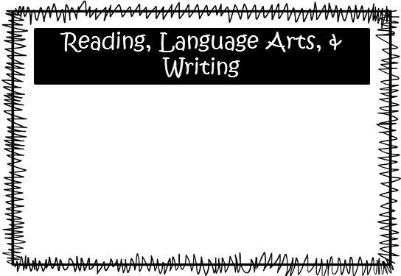.the

Science: We are exploring constructive and destructive forces that affect the land.

Lo’s classes will have a test on Monday the 23rd. We will be unearthing the role of technology in limiting damage and predicting changes to the Earth’s surface.

Social Studies: We remember the USS Maine and find a faster route to the West to examine America as an expanding World Power. Lo’s classes will test over the Turn of the Century on Tuesday, October 31st.

**Smith:** We are working with place value going up through billions and going down as small as thousandths. We will begin changing decimals to fractions and vice versa and will also start adding and subtracting numbers with decimals.

**McEntire’s Homeroom:** We are working on reading, writing, and adding decimals through hundredths. We will be moving into multiplying decimals.

**Wilds’ Homeroom:** We are working on estimating and multiplying decimals and will be moving into dividing numbers with decimals.

Please consider donating Vienna sausages for Snack Packs!

Upcoming Events:

* October 30th-November 3rd—Wild West Book Fair
* October 31st, Donuts for “Dudes” and Dress Up Day
* November 7th—Inservice Day, no school for students
* November 10th—PTO Santa Night at 6:00PM
* November 20th-24th—Thanksgiving Holidays

Email Addresses:

[Amandalo@pickenscountyschools.org](mailto:Amandalo@pickenscountyschools.org)

[Ashleypatterson@pickenscountyschools.org](mailto:Ashleypatterson@pickenscountyschools.org)

Brandimcentire@pickenscountyschools.org

[Carolsmith@pickenscountyschools.org](mailto:Carolsmith@pickenscountyschools.org)

Jenniferwilds@pickenscountyschools.org

We are continuing with our novel, *Bud, Not Buddy*. We will be focusing on our inferencing and summarizing skills. We will have a vocabulary test on Friday, October 27th. The study guide is in your child’s Friday folder. In writing, we will continue to focus on improving our ability to respond to constructed responses using the TEACH approach. We will also continue to discuss comma rules and compound and complex sentences.

Math