ta

A Peek at Our Week

Week of August 1-5, 2016



**Ah-“Mason” Happenings in the Fifth Grade**

Week of October 16-20



Follow our school on Twitter @HillCityHawks.

Dear Parents,

On Wednesday, October 18th, the fifth grade is hosting a 50s Dance for fourth and fifth grade students. A permission form was sent home earlier this week. Please make sure your child has returned this form if he or she plans to attend. Also, students are allowed to dress up in 50s attire on this day.

Tutoring in reading and math starts next Tuesday, October 17th. If your child receives a letter about receiving tutoring services, we strongly encourage you to take advantage of this opportunity. Tutoring will give your child additional support in both subjects from a certified teacher. Please let your child’s homeroom teacher know if you have any questions.

Thank you,

Fifth Grade Teachers

 We



Things to Know

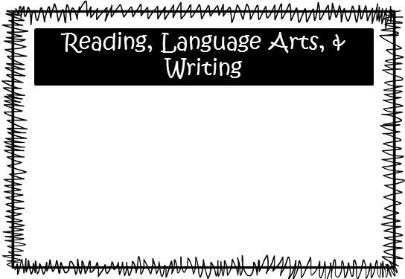

Science: We are continuing our studies of landforms. This topic will take several weeks to explore. Lo’s classes will explore the forces that change the Earth’s surface.

Social Studies: We will begin to explore the technological innovations after the Civil War and how America changed due to the contributions of the Wright Brothers, George Washington Carver, Alexander Graham Bell and Thomas Edison.

**Smith:** We are working with place value going up through billions and going down as small as thousandths. We will begin changing decimals to fractions and vice versa and will also start adding and subtracting numbers with decimals.

**McEntire’s Homeroom:** We are working on reading, writing, and adding decimals through hundredths.

**Wilds’ Homeroom:** We are working on estimating and multiplying decimals.

Please consider donating Vienna sausages for Snack Packs!

Upcoming Events:

* October 18th, 50’s Dance for 4th and 5th Grade and 50’s Dress Up Day
* October 30th, Book Fair begins
* October 31st, Donuts for “Dudes” and Dress Up Day

Email Addresses:

[Amandalo@pickenscountyschools.org](mailto:Amandalo@pickenscountyschools.org)

[Ashleypatterson@pickenscountyschools.org](mailto:Ashleypatterson@pickenscountyschools.org)

Brandimcentire@pickenscountyschools.org

[Carolsmith@pickenscountyschools.org](mailto:Carolsmith@pickenscountyschools.org)

Jenniferwilds@pickenscountyschools.org

We will continue reading *Bud, Not Buddy*, and students will continue to participate in daily discussions that monitor their comprehension and challenge them to think critically about what they are reading. Also, we are still working on responding to constructed responses. Through teacher modeling, working with a partner, and independent practice, students are being exposed to exemplar responses and being given the opportunity to practice their skills. To this point, we are very pleased with the progress that we are seeing! Great job!

Math