ta

A Peek at Our Week

Week of August 1-5, 2016

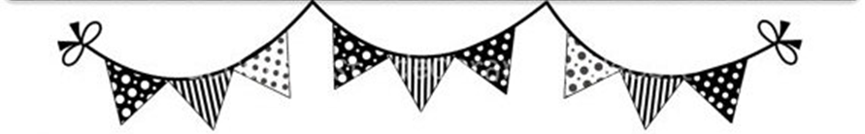

**Ah-“Mason” Happenings in the Fifth Grade**

Week of August 21-25



Follow our school on Twitter @HillCityHawks.

Dear Parents,

As we get more involved in 5th grade curriculum, please do not hesitate to reach out to us if you have any questions or concerns about content, expectations, or your child’s performance. As study guides are sent home, please encourage your child to review and practice good study skills. If we can do anything, please let us know. We are here to help as much as we can!

If you’ve been waiting to purchase a HCES spirt wear shirt, please know that our PTO will be placing the one and only order for additional shirts at the end of next week. Your order forms must be turned in by **Wednesday, August 30th**.

Lastly, please remember that we will not have school on Monday, August 21st due to the eclipse.

Thank you,

Fifth Grade Teachers

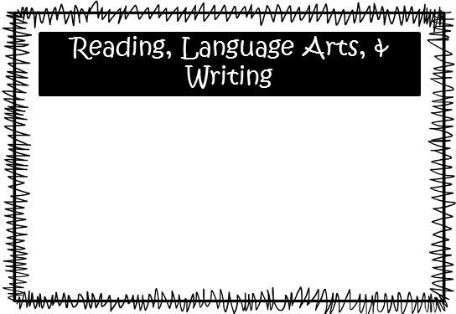

Math

Things to Know



We will continue to read our novel, *The Mostly True Adventures of Homer P. Figg*. We will focus on improving our comprehension and fluency as we read, and students will continue to improve their writing skills through responding to literary prompts from our novel. Because of our short week, we will NOT have any new vocabulary; however, students in Mrs. McEntire’s homeroom will test over vocabulary words from week 2 on Friday, August 25th. We are still practicing writing compound and complex sentences, as well as, dialogue and reviewing the parts of speech.

Upcoming Events:

* August 21st, No School
* August 25th, PTO Movie Night at 6:00 PM
* August 31st, Progress Reports
* September 4th, Labor Day, No School
* September 11th, Parent Academy (more information to follow)

Email Addresses:

[Amandalo@pickenscountyschools.org](mailto:Amandalo@pickenscountyschools.org)

[Ashleypatterson@pickenscountyschools.org](mailto:Ashleypatterson@pickenscountyschools.org)

Brandimcentire@pickenscountyschools.org

[Carolsmith@pickenscountyschools.org](mailto:Carolsmith@pickenscountyschools.org)

Jenniferwilds@pickenscountyschools.org

We will start division and will begin finding patterns of division. We are not having math homework, so please take this time to help your child with basic multiplication facts. We do not spend a lot of class time learning facts in the 5th grade. We expect your child to know these facts and be able to use them as we multiply, divide, work with fractions, and convert measurements. We appreciate your support with this matter.

Science: We will continue comparing plant and animal cells. We will also be using microscopes to observe a variety of cells. We will be discussing microorganisms, as well.

**\*\*\*Students in Lo’s science classes will have a cells unit test on August 23rd.**

Social Studies: We will begin focusing our attention on the Civil War. Students will investigate the different historical perspectives of important people throughout the time period. A study guide can be found in your child’s folder.