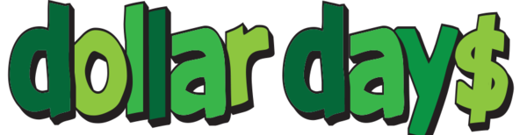
Parents,
Beginning this month, fifth grade teachers will be sponsoring monthly Dollar Days. On these designated days, our fifth grade students may participate in the chosen theme by donating a dollar. Proceeds from Dollar Days will go directly towards funding fifth grade activities throughout the year, such as, making Christmas ornaments and gingerbread houses. All students will be rotating to each fifth grade teacher to make five different ornaments or craft project. Funds will also go towards a fun and exciting end of the year send off for our fifth grade Hawks. Our first Dollar Day will be on Friday, November 10th. On this day, students may choose to donate $1 in exchange for bringing in a small stuffed animal or wearing a hat all day. If your child wants to do both, it will be $1 each. As we plan for more Dollar Days, we will send additional information home.
In addition, if you would like to donate any of the needed items for our ornaments or gingerbread houses, please find our wish list below. Please know that we greatly appreciate any and all help that you can provide. As always, thank you so much for all you do!
- Gingerbread Houses Wish List: graham crackers, white icing, m&ms, candy canes, gummy bears, gumdrops, chocolate chips, sprinkles
- Ornaments Wish List: bags of kid size white tube socks, assortment of buttons, large bottles of acrylic paint (white, red, and green), red ribbon, empty toilet paper or paper towel rolls, small paper plates, silver glitter, Epsom salt

Kind regards,
Fifth Grade Teachers

